Hotel |  | Rate  Information | Distance from  SAS Campus
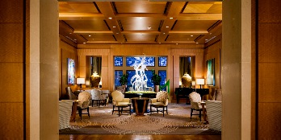 | Umstead Hotel and Spa  100 Woodland Pond  Cary, NC 27513  919-447-4000  866-877-4141 | SAS Client Rate & Government Rate | Located on  SAS Campus
Located on SAS Campus and within minutes
of restaurants/shopping
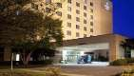 | Embassy Suites RTP  201 Harrison Oaks Blvd  Cary, NC 27513  919-677-1840  800-EMBASSY | SAS Client Rate & Government Rate | 1 mile  (4 minutes)
Located across the street (Harrison
Ave) from SAS Campus
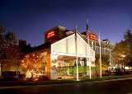 | Hampton Inn & Suites  Raleigh/Cary  111 Hampton Woods Lane  Raleigh, NC 27607  919-233-1798 | SAS Client Rate & Government Rate | 2.5 miles  (6 minutes)
 |  | Includes free hot breakfast & Wi-Fi Located 9 miles from RDU and minutes from PNC Arena and Crabtree Mall
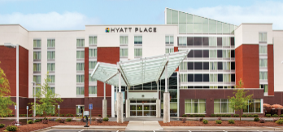 | Hyatt Place Raleigh West  710 Corporate Center Drive  Raleigh, NC 27607  919-233-2205 | SAS Client Rate & Government Rate  Includes free hot breakfast & Wi-Fi | 3 miles  (6 minutes)
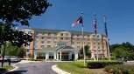 | Hilton Garden Inn - RDU  1500 RDU Center Dr  Morrisville, NC 27560  919-840-8088 | Located one mile from RDU Airport.  Complimentary Wi-Fi | 4 miles  (9 minutes)
 |  | SAS Client Rate & Government Rate
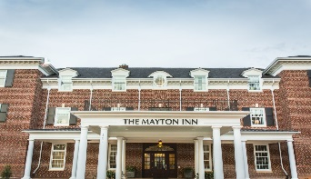 | The Mayton Inn  301 S Academy St  Cary, NC 27511  919-670-5000 | Boutique hotel located in downtown Cary, walking distance to a variety of dining, shopping and breweries. In-house restaurant, bar, spa, free Wi-Fi. | 4.4 miles  (11 minutes)
 |  | SAS Client Rate & Government Rate
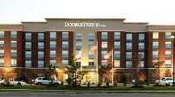 | Doubletree Hilton Raleigh-Cary  500 Caitboo Avenue  Cary, NC, 27518  919-239-4777 | Located in Crossroads Shopping Center and  15 minutes from RDU | 8 miles  (13 minutes)
 |  | SAS Client Rate & Government Rate
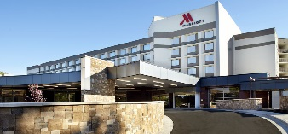 | Raleigh Marriott Crabtree  4500 Marriott Drive  Raleigh, NC 27612  919-781-7000 | Located in walking distance to Crabtree Valley Mall and just minutes by car from downtown Raleigh | 9 miles  (14 minutes)
 |  | Government Rate
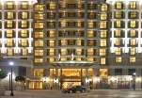 | Renaissance Raleigh North Hills  4100 Main at North Hill St  Raleigh, NC 27609  919-571-8773 | Located in the upscale North Hills  shopping center with dozens of  Restaurants and shopping opportunities | 10 miles  (15 minutes)
 |  | SAS Client Rate & Government Rate
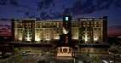 | Embassy Suites Brier Creek  8001 Arco Corp. Dr  Raleigh, NC 27617  919-572-2200 | Located in upscale shopping/dining area (Brier Creek). 3 miles from RDU | 10 miles  (15 minutes)
= Client Favorite

* SAS Customer/Client Rates are subject to a 12.75% room tax and are based on availability – Please confirm with hotel at time of reservation
* Government rates are based on availability and are only available to federal employees with proper ID, traveling on federal government business

